H.T No
Regulations:
A18

Sreenidhi Institute of Science and Technology
(An Autonomous Institution)
Code No: 7AC07 Date: 30-Dec-2022 (FN)

B.Tech II-Year II- Semester (A18) Special Supplementary Examination - December-2022
CONTROL SYSTEMS (EEE)

Time: 3 Hours Max.Marks:70

Note: a) No additional answer sheets will be provided.
b) All sub-parts of a question must be answered at one place only, otherwise it will not be valued.
c) Missing data can be assumed suitably.

ANSWER ANY 5 OUT OF 8 QUESTIONS. EACH QUESTION CARRIES 14 MARKS.

Bloom's Cognitive Levels of Learning (BCLL)
Remember | L1 | Apply | L3 | Evaluate | L5
Understand | L2 | Analyze | L4 | Create | L6

 |  |  | BCLL | CO(s) | Marks
1. | a) | Obtain the transfer function relating C(s) and R(s) for the block diagram shown in below figure.  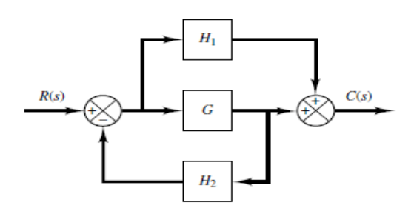 | L3 | CO1 | [7M]
 | b) | Explain working of Synchros. | L2 | CO1 | [7M]
2. | a) | A unity feedback system is characterized by an open -loop transfer function  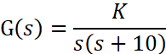  Determine the gain K so that the system will have a damping ratio of 0.5. For this value of K, determine the settling time, peak overshoot and time to overshoot for a unit step input. | L4 | CO2 | [7M]
 | b) | How are control systems classified depending on the value of damping? | L2 | CO2 | [7M]
3. | a) | Determine the stability of the system represented by s⁶+2s⁵+s⁴+2s³+3s²+4s+5 using Routh stability criterion. | L3 | CO3 | [7M]
 | b) | A unity feedback control system is characterized by the open loop transfer function . Calculate the range of values of K for the system to be stable and what is marginal value of K for stability. | L4 | CO3 | [7M]
4. | a) | Draw the Bode plot for the following transfer function and determine the system gain crossover frequency, phase crossover frequency, gain margin and phase margin. Also determine the value of K for a phase margin of 45⁰.  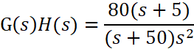 | L4 | CO4 | [7M]
 | b) | Define resonant peak and resonant frequency. | L1 | CO4 | [7M]
5. | a) | Derive expression for the transfer function of a Lead compensator. | L3 | CO5 | [7M]
 | b) | Explain the lag compensator technique. | L2 | CO5 | [7M]
6. | a) | Given the system 𝑥̇(t ) = A x(t )+ B u(t ), Y(t) = C x(t) Where  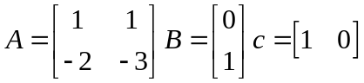  Determine the state controllability, output controllability and observability of the system | L5 | CO6 | [7M]
 | b) | Derive the state space model for a series RLC circuit excited with a source of V(t) | L3 | CO6 | [7M]
7. | a) | Why negative feedback is preferred in control systems? | L2 | CO1 | [5M]
 | b) | What is the location of poles for different types of damped systems? | L1 | CO2 | [5M]
 | c) | Explain procedure steps to draw root locus. | L2 | CO3 | [4M]
8. | a) | What are the advantages of frequency response analysis? | L1 | CO4 | [5M]
 | b) | What is the effect of addition of a zero to G(s)H(s) on the Nyquist plot? | L4 | CO5 | [5M]
 | c) | Relate transfer function of a system to it’s state model. | L2 | CO6 | [4M]

-- 00 -- 00 –

